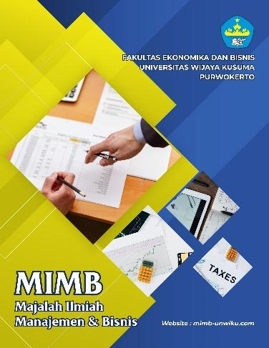 | Article Type: Research Paper  Title in Title Case Format  Times New Roman - 12 - Bold  (Maximum 14 words)  Authors1¹⁾, Author2²⁾, etc. [Times New Roman - 10 – Bold and Full Name]  ABSTRAK  Abstrak dalam bahasa indonesia meliputi pokok permasalahan, tujuan penelitian, metode / pendekatan dan hasil penelitian. Abstrak terdiri dari satu paragraf, tidak lebih dari 200 kata. (Times New Roman - 11 - spasi tunggal ).  Kata kunci: Maksimal lima kata kunci dipisahkan dengan titik koma [Times New Roman - 11 - spasi tunggal ]  ABSTRACT  is in English covering the central issues of the study, the objectives, the methods/approaches and the results of the study. Abstract consists of one paragraph, not to exceed 200 words. (Times New Roman – 10 – single space – italic).  Keywords: A maximum of five keywords separated by semicolon [Times New Roman – 11 – single space – italic]
Vol xx No x, pp xx-xx

AFFILIATION:
¹Faculty, University (of the first author)
email: author_1@abc.ac.id (official email is recommended)
²Faculty, University (of the second author)
email: author_2@cde.ac.id (official email is recommended)

*CORRESPONDENCE:
Email corresponding author.

THIS ARTICLE IS AVALILABLE IN:
http://mimb-unwiku.com/index.php/mimb

ARTICLE HISTORY
Received:
[filled by the journal manager]
Reviewed:
[filled by the journal manager]
Revised:
[filled by the journal manager]
Accepted:
[filled by the journal manager]

HOW TO CITE:
[filled by the journal manager]

INTRODUCTION

Introduction explains the background on particular issues and the urgency and rationalization of the activities. In introducing the research concern, the writer should provide a clear rationale for why the problem deserves new research, placing the study in the context of current knowledge and prior theoretical and empirical work on the topic. Moreover, the novelty of the research should explained in the paragraph (Times New Roman, 11 pts, single space, justify alignment).

LITERATURE REVIEW

This section discusses the study of journals, articles, books and other relevant sources. If necessary, the formulation of hypotheses is presented in this section. The formulated hypothesis must be based on adequate logic and supported by the results of previous research. (Times New Roman, 11 pts, single space, justify alignment).

RESEARCH METHOD

In both quantitative and qualitative research, the use of appropriate methods of participants sampling, study design, measures, and statistical analysis critically influences the study’s methodological soundness. A good methodology should be clean and clear. Clean means the use of appropriate, valid, and unflawed methods of sampling and use of instruments, procedures, and analysis. Clear means the ideal method is written in a clear manner, such that another researcher could duplicate the study (Times New Roman, 11 pts, single space, justify alignment).

RESULT AND DISCUSSION

This section presents the results of the study that may be equipped with tables, figures (graphs), and/or diagrams (Times New Roman, 11 pts, single space, justify alignment).
Tables and figures should be placed as close to their reference point in text as possible and they should be numbered consecutively as they appear in the text. All Figures and Tables must have titles and must be referenced from within the text. We remark that, all Tables and Figures should be included in one file, and integrated into the text at the appropriate points (not in an appendix), unless there are large and interrupt the flow of the text. In this case they should be appended and numbered consecutively in Arabic numerals with a descriptive caption. Appendix should be placed at the end of your paper, after the references (Times New Roman, 11 pts, single space, justify alignment).
Avoid colour images as the journal is printed in black and white. Illustrations should be preferably included into the text as objects. They should be consecutively numbered in Arabic numerals with the heading always above the Table or Figure; they should be typed in bold font 11, single line spacing and the source beneath, also single line spacing. Please leave one line empty before and after every illustration and/or Table. (Times New Roman, 11 pts, single space, justify alignment).
Table 1. Production Value Based on Industrial Classification in Purwokerto City on the basis of Current Pricing (Percent)
Sector | Production Value  (in thousands) | Sector Contribution  ( %)
Food and Beverages | 90,852,476 | 5.4
Tobacco Manufacturing | 842,725 | 0.1
Textile | 143,110,910 | 8.6
Garment | 364,633,106 | 21.8
Leather and Leather Products | 77,840,905 | 4.7
Wood, Wood Products, Cane Ware | 144,138,380 | 8.6
Paper and Paper Products | 333,046,528 | 19.9
Publishing, Printing and Reproduction | 138,812,242 | 8.3
Chemical and Chemical Products | 295,888,623 | 17.7
Rubber and Rubber Products | 81,766,857 | 4.9
 | 1,670,932,752 | 100
Source: Survey on Industries in S
Total
urakarta
Writing Figure
Title is written under the figure and graph using left margin. For example:
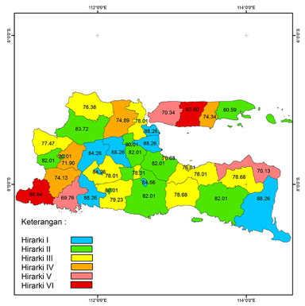
Figure 1. Local Spatial Autocorrelation of Food and Beverages Map Cluster

This section discusses the results of data analysis, interprets the findings systematically, relates them to the relevant referral sources. It contains specific or unique findings from the results of the study. Any possible follow-up activities may also be addressed in this section (Times New Roman, 11 pts, single space, justify alignment).

CONCLUSION

In a conclusion, you summarize your findings and explain the implications of your work. Conclusion contains no new data or findings. You may also include Recommendations for improvements to the apparatus or method, or suggestions for future research on the subject at hand. (Times New Roman, 11 pts, single space, justify alignment).

ACKNOWLEDGEMENT (IF NEEDED)

Collate at the end of the article before the references. List here those individuals who provided help during writing the paper (e.g., funding your research project, providing language help, writing assistance or proof reading the article, etc.) (Times New Roman, 11 pts, single space, justify alignment).

REFERENCES

In the references section, only include previous works that cited in the text. References should be cited in the text according to the APA reference system (www.apastyle.org), that is, use the last name of the author(s), the date of publication and, following quoted material. The reference list should include every work cited in the text. Please ensure that dates, spelling, and title used in the text are consistent with those listed in the references. Please use Reference Manager Applications like EndNote, Mendeley, Zotero, etc.
APA publishes references in a hanging indent format, meaning that the first line of each reference is set flush left and subsequent lines are indented. Some examples are as follow.
Books
Mankiw, N. G. (2014). Principles of Macroeconomics (seventh edition). United States: Cengage Learning
Journal
Witjaksono, M. (2014). Siparti 3-S, Triple Helix, and Social Capital in Strengthening Local Competitive Industries in Indonesia. Journal of Economics and Sustainable Development, 5(3), 21-33.
Wulandari, B., & Narmaditya, B. S. (2015). Dampak Literasi Keuangan Pada Akses Layanan Keuangan: Studi Pada Kepemilikan Asuransi di Malang. Jurnal Ekonomi & Studi Pembangunan, 7(1), 63-67.
Proceedings
Wulandari, D & Narmaditya, B. S. (2016). Using Simulation Methods to Improve Student Learning. 2nd International Conference on Education: 1, 1-6. Bangkok, Thailand: TKIIM.
Newspaper article
Brummitt, C. (2016). This Asian Lets You Borrow Cash and Pay in Trash. Retrieved from https://www.bloomberg.com
Newspaper article-without an author
Internet Pioner to oversee network redesign. (2017). Waste Bank Cut Down Trash Volume in Central Jakarta. Retrieved from http://www.thejakartapost.com
Working Paper
Lusardi, A., & Tufano, P. (2009). Debt literacy, financial experience, and overindebtedness. NBER Working Paper 14808.

